**Using Pascal’s Triangle and Binomial Theorem to expand Binomials**

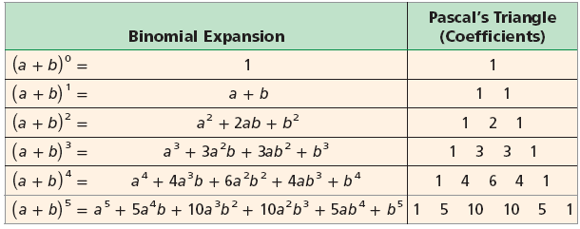

1. 2. 4

3.

**Polynomial long division** is a method for dividing a polynomial by another polynomial of a lower degree. It is very similar to dividing numbers.

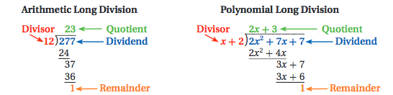

**Numerical Long Division**

|  |
| --- |
| **Fill in the boxes.**  Which number is the…  Dividend?  Divisor?  Quotient?  Remainder?  2  3  1  0  5  2  4 |

**How to Divide by Polynomials**

**Prepare:**

1. Write the problem in “long division form”. That means you change  or  into  form.
2. Put **0s** as placeholders for any missing term in the divisor and dividend.

**Process:**

1. **D**ivide the **first term** of the dividend by the **first term** of the divisor. Line up the result **above the like term** in the dividend.
2. **M**ultiply the result of the division by the **entire** divisor. Write it below the dividend’s first term.
3. **S**ubtract the **entire** product from the terms above it.
4. **B**ring down the next term from the dividend.
5. Repeat this process until you are left with a remainder (or 0). Write the remainder as a **fraction with the divisor as the denominator**.

**Guided Practice:**

1. $(2x^{3} – 9{x }^{2}+ x + 3) ÷ (2x + 1)$

**Simplify the polynomial by performing the indicated operation.**

1. 2. 4

3. 4.

5.  6. 

**Synthetic division** is a process that can be used as an alternative to long division. Synthetic division

can be used when the divisor is a _____________ binomial with a leading ________________ of one.

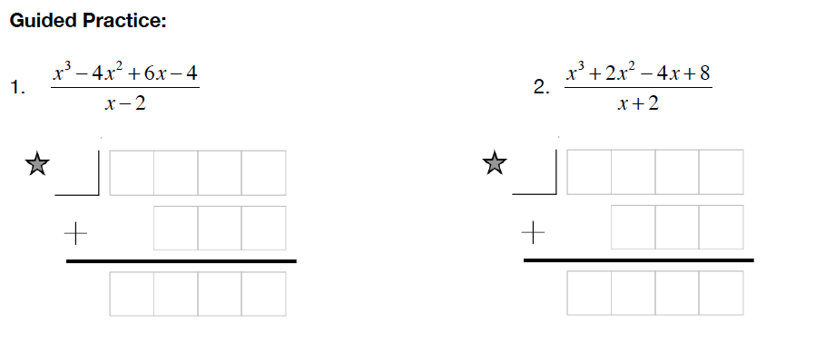

Divide using long and synthetic division. Determine whether the given binomial is a factor of p(x).

1. 2.

**Factor Theorem**

Let $p\left(x\right)={-3x}^{4}+ x^{3}+8x^{2}+5x+18.$ Evaluate $p\left(2\right).$ What does your answer tell you about the factors of $p\left(x\right)$.