Warm Up: Identify the type of problem. Write down the steps to solving the following problems. Simplify or solve completely and find the values of x for which the expression or equation is undefined.

1. $\frac{2x}{x^{2}-36}+ \frac{x+4}{x+6}$

2. $\frac{-2x}{x-1}+\frac{x}{3}=\frac{5}{x-1}$

3. $\frac{2x^{2}-7x-4}{x^{2}-9}÷ \frac{4x^{2}-1}{8x^{2}-28x+12}$

A function whose rule can be written as a ratio of two polynomials, $f\left(x\right)=\frac{p(x)}{q(x)},$ such that $q(x)≠0$ is called a _________________ _________________.
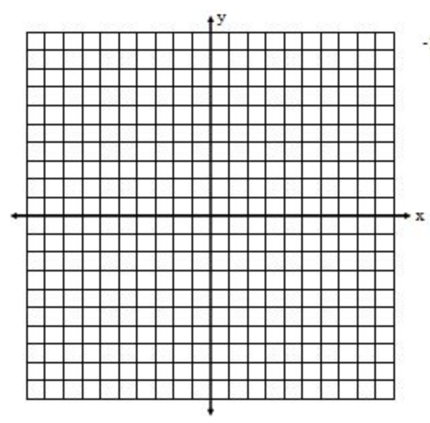
x | $$f(x) = \frac{1}{x}$$
-2
-1
$$-\frac{1}{2}$$
0
$$\frac{1}{2}$$
1
2

The parent rational function is:
$f\left(x\right)= \frac{1}{x}$

Its graph is a hyperbola, which has two separate branches. A rational function may have horizontal and vertical asymptotes. The function $f\left(x\right)=\frac{1}{x}$ has a vertical asymptote at $____________$ and a horizontal asymptote at $______________.$

Transformation of Rational Functions

Rational Functions can be transformed as follows: $g\left(x\right)= \frac{a}{(x-h)}+k$

Describe the tranformation and graph the following. Identify the domain, range and asymtotes.
1. 2. $f\left(x\right)= \frac{1}{x+2}$ $f\left(x\right)= \frac{1}{x-3 }+2$

Transformations: Transformations:

Vertical Asymptote: Vertical Asymptote:

Domain: Domain:

Horizontal Asymptote: Horizontal Asymptote:
Range: Range:
Exploration:
Part 1: Given, $p\left(x\right)= x^{2}+x-6, q\left(x\right)=x+2$

$$h\left(x\right)= \frac{p(x)}{q\left(x\right)}=$$
- Factor the numerator to find the zeros of $p\left(x\right).$

Factor the denominator to find the zeros of $q\left(x\right)$.

2. Graph the function $g\left(x\right)$ using your graphing calculator. What do you notice about the roots of $p\left(x\right) and q\left(x\right)$ based on the graph?

Zeros of $h\left(x\right)$ are: y-intercept:

Vertical Asymptotes of $h\left(x\right)$ are:

Domain:

Range:

Part 2: Now graph $g\left(x\right)= \frac{q(x)}{p\left(x\right)}=$

1. Graph the function $g\left(x\right)$ using your graphing calculator. What do you notice abouit the roots of $p\left(x\right) and q\left(x\right)$ based on the graph?

Zeros of $g\left(x\right)$ are: y-intercept:

Vertical Asymptotes of $g\left(x\right)$ are:

Domain:

Range:

Horizontal Asymptotes:
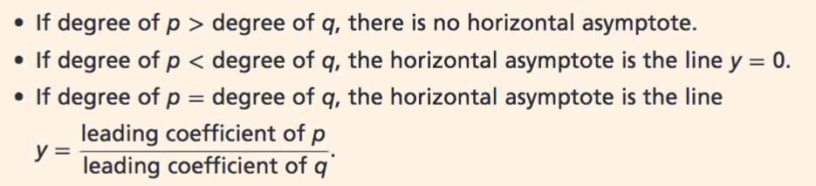

Identify zeros and any asymptotes or holes for each function.
1. $f\left(x\right)=\frac{2x+6}{4x-8}$ 2. $f\left(x\right)= \frac{x-1}{x^{2}-9}$ 3. $f\left(x\right)= \frac{x^{2}-4}{x-2}$

4. $f\left(x\right)= \frac{2x^{2}}{x^{2}-x-6}$ 5.$f\left(x\right)=\frac{x^{2}+1}{x-2}$

Exploration II: Use your graphing calculator to graph the functions below. Identify the zeros, vertical and horizontal asymptotes, domain and range.

$$1. h\left(x\right)= \frac{3x-9}{x+3}$$

Zeros: y-intercept:

Vertical Asymptote:

Domain:

Horizontal Asymptote:

Range:
$2. h\left(x\right)= \frac{3x^{2}+3x-6}{x^{2}-x-6}$

Zeros: y-intercept:

Vertical Asymptote:

Domain:

Horizontal Asymptote:

Range:

$$3. g\left(x\right)=\frac{x^{2}+2x-3}{x^{2}-x-2}$$

Zeros:

Vertical Asymptote:

Domain:

Horizontal Asymptote:

Range:

SUMMARY:
The process for graphing rational functions of the form: $f\left(x\right)=\frac{p(x)}{q(x)}$ is:
- Identify the __________________. Find the y-intercept: $f\left(0\right).$
- Identify the holes, ______________________and __________________________ asymptotes.
- Plot the _________________________ and the _______________________.
- Use a table of values to identify additional _______________________ on the function’s graph.
- Draw each branch with a __________________ __________________________.

